Quantified Student

Weather Data Microservice

Created by G. Malisz

Content

1. Version History 2

2. Overview 2

3. Design 2

3.1. Domain-Driven Design 2

3.2. Level 3 of C4 model 3

3.3. UML 4

4. Weather Data 4

5. Data Source Change 5

6. Conclusion 5

# Version History

|  |  |  |  |
| --- | --- | --- | --- |
| Version | Date | Author | Comment |
| 0.1 | 02.06.2023 | G. Malisz | Structure, Overview, Design, Weather Data, Data source change, Conclusion. |

# Overview

The Weather Data Microservice is a vital component of the student performance dashboard, providing stakeholders with requested weather data parameters. It offers both historical weather data and forecasts up to 16 days ahead from Open-Meteo, enabling stakeholders to analyse the potential impact of weather conditions on student performance.

GitHub link [**https://github.com/quantifiedstudent/WeatherDataMicroservice**](https://github.com/quantifiedstudent/WeatherDataMicroservice)

# Design

## Domain-Driven Design

The Weather Data Microservice was developed using Domain-Driven Design (DDD) software design principles to streamline and organize the development process. By following DDD, the microservice was designed with a clear focus on the weather domain and its specific business logic. This approach helped to simplify the development process by breaking down complex functionalities into manageable and cohesive domains. DDD facilitated the identification and modelling of key concepts, leading to a more structured and maintainable codebase. Additionally, the separation of concerns and modular design principles inherent in DDD ensured that the Weather Data Microservice could be easily integrated into the overall architecture of the student performance dashboard. Overall, applying DDD to the development of the Weather Data Microservice helped streamline the process and resulted in a well-structured and domain-centric microservice.

## Level 3 of C4 model

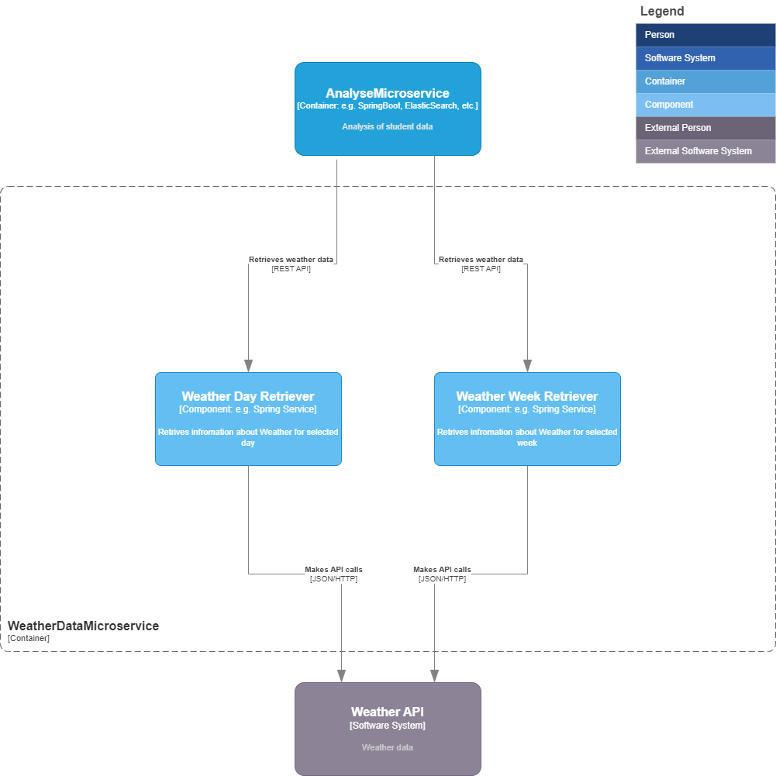

## UML

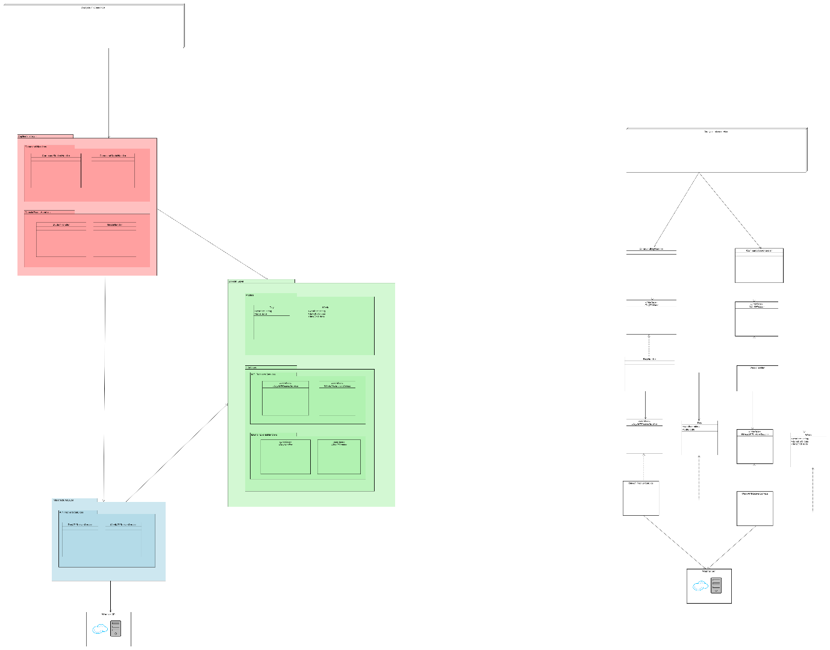

# Weather Data

The Weather Data Microservice provides daily historical weather data and forecasts up to 16 days. Weather parameters accessible form Weather Data Microservice are:

* Date
* Mean Temperature
* Sunrise
* Sunset
* Precipitation sum
* Rain sum
* Snowfall sum
* Windspeed

The Weather Data Microservice introduces internal API endpoints that grant access to data from other microservices within the Quantified Student System. This integration allows for convenient retrieval of the required data, minimizing unnecessary traffic and reducing computing power. By providing targeted and specific data access, the Weather Data Microservice eliminates the need to process and transmit irrelevant or redundant information, thereby optimizing system performance and resource utilization.

# Data Source Change

During the development of the Weather Data Microservice, a change was made to the data source based on stakeholder requirements. Originally, the microservice utilized the Meteostat data source. However, due to specific stakeholder needs, including the inclusion of sunrise and sunset data in the weather information, the decision was made to switch to the Open-Meteo data source. Open-Meteo provided the necessary additional data parameters, allowing for a more comprehensive and valuable weather data offering within the microservice. This change in data source ensured that stakeholders could access the complete set of weather information they required for their analysis and decision-making processes regarding student performance.

Incorporating the Open-Meteo data source into the Weather Data Microservice was a seamless process due to the structured software design (DDD). The modular architecture and separation of concerns within the microservice allowed for easy switching between data sources, facilitating the transition from Meteostat to Open-Meteo. Despite the change in data source, the structured design ensured that the necessary adjustments could be made efficiently. However, it is important to note that incorporating Open-Meteo introduced the need to retrieve data from two Open-Meteo API endpoints. This is because the historical weather API in Open-Meteo can have a delay of up to 5 days in providing the complete data set. Despite this slight complexity, the structured software design of the microservice facilitated the integration of the Open-Meteo data source and enabled the delivery of comprehensive and accurate weather data for the student performance dashboard.

# Conclusion

In conclusion, the Weather Data Microservice stands as an efficient and robust component within the student performance dashboard. Its implementation using Domain-Driven Design (DDD) principles has played a pivotal role in its success. The DDD design approach has facilitated the creation of a well-structured and organized microservice, allowing for efficient development, scalability, and extensibility. The modular design of the microservice enables easy replacement of the data source, as demonstrated by the transition from Meteostat to Open-Meteo. The inherent flexibility of the DDD design has ensured that the Weather Data Microservice can seamlessly accommodate changes in the data source and easily integrate new features or functionality.